SendGrid Configuration

# Configure SendGrid in Azure

With an Azure subscription, SendGrid can be configure to send email for free with a limit of 25K email per month. SendGrid also offer several paid plan with higher limits.

The following describes the steps to configure SendGrid.

1. Log into <http://portal.azure.com>
2. Click on “Create a resource” and search for “SendGrid Email Delivery”

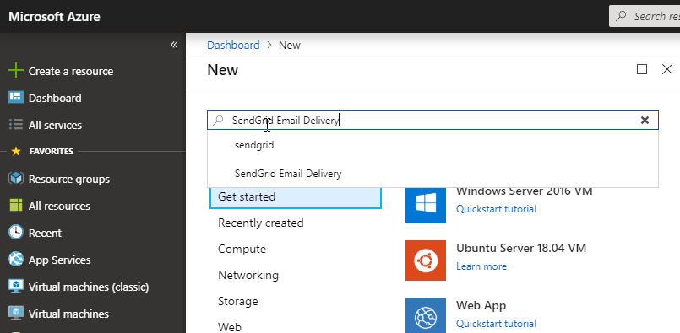

1. An introduction page displays. Click on “Create”

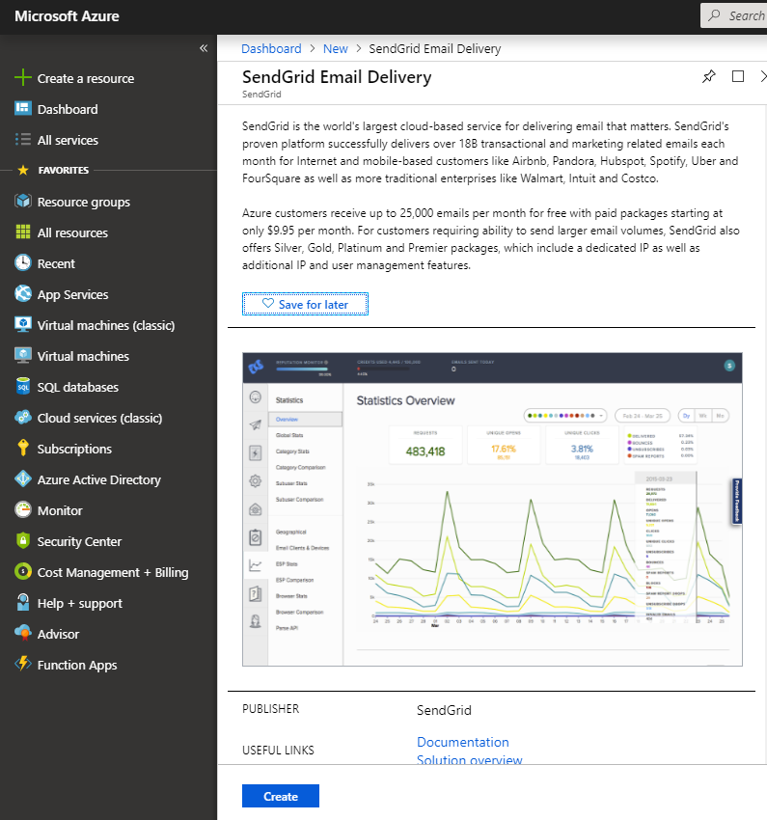

1. Provide the information requested on the form.

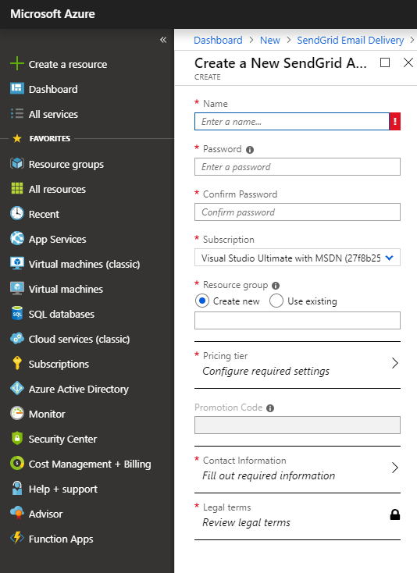

1. The SendGrid account is created. The screen displays an overview of the account

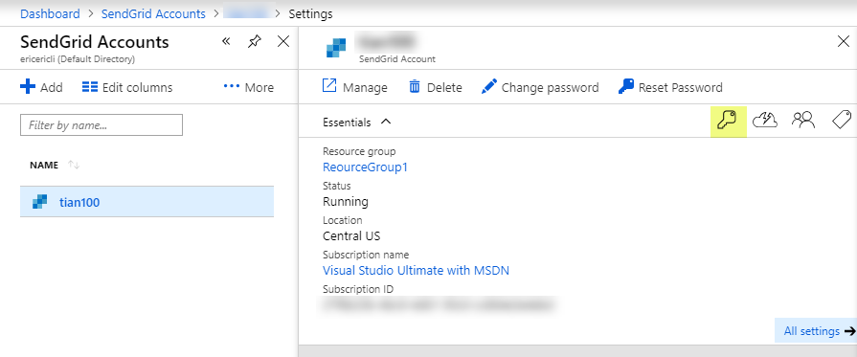

1. Click on the key icon (highlighted on the screenshot), the SendGrid account information displays. Please note that your user name with SendGrid has been created automatically in the following highlighted field. You will need the user name and the password you crated to sign into SendGrid.

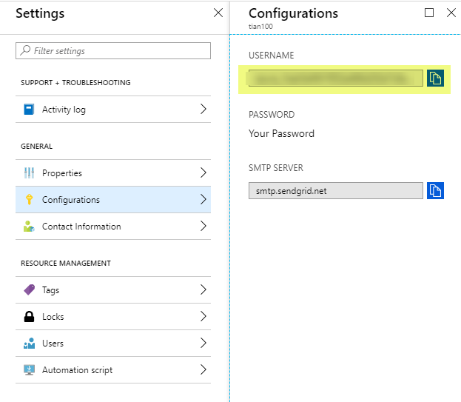

## Configure SendGrid

1. Log in by going to <https://app.sendgrid.com> and provide the username and password.

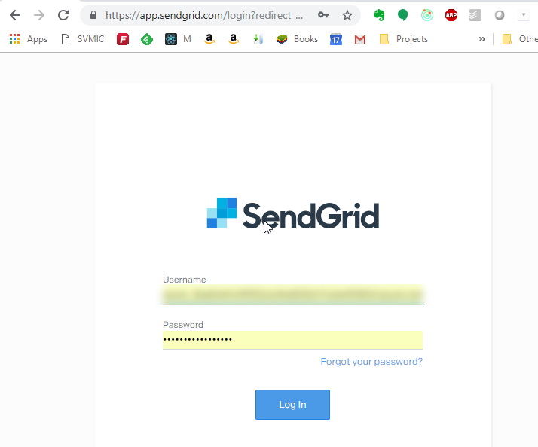

1. The summary screen displays.

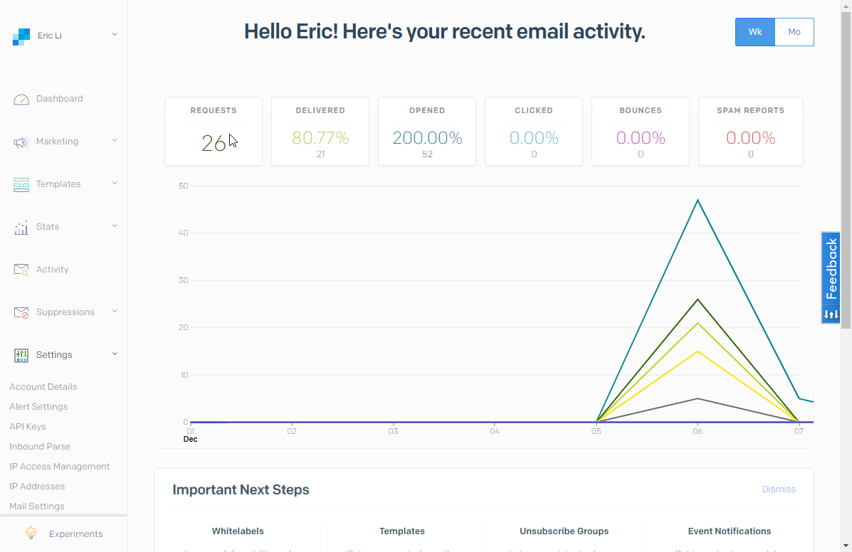

1. To obtain the API key, go to Setting/API key on the left. You can create multiple API keys with different permissions here. Please note that you need to keep a copy of the API key once it is generated. It will not be displayed again for security reasons.

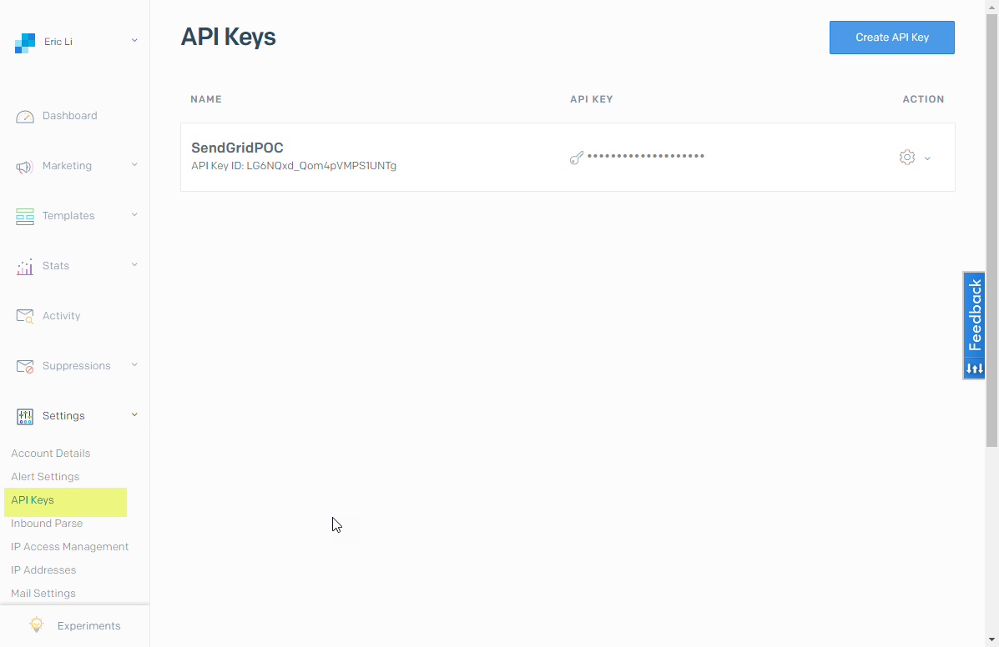

1. SendGrid provide a rich feature set to manage the email delivery and tacking. The following screen shows a Activity Feed showing messages have been opened.

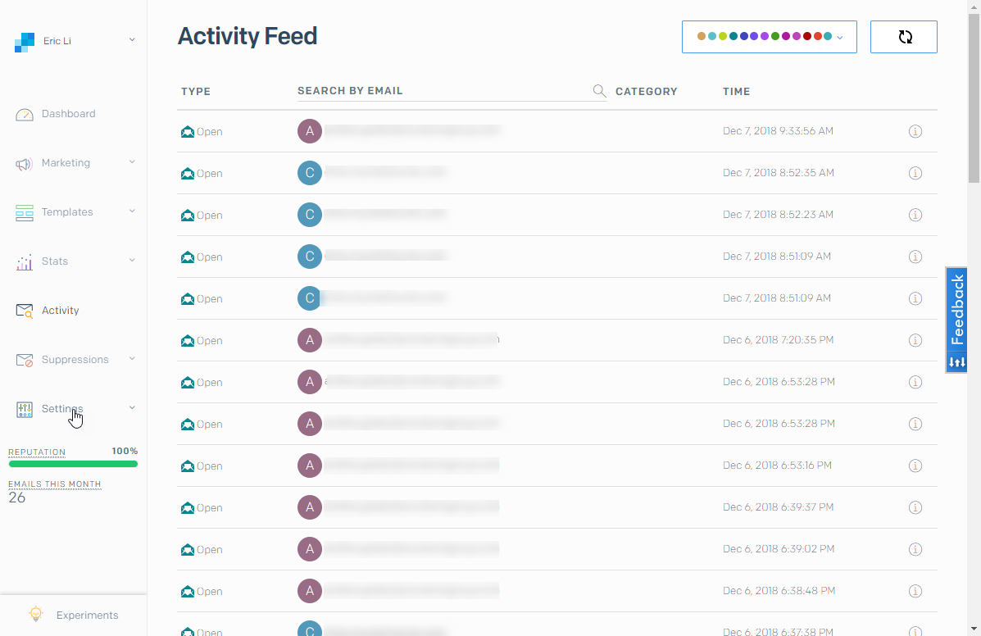

This screen can also provide information for additional status as shown here.

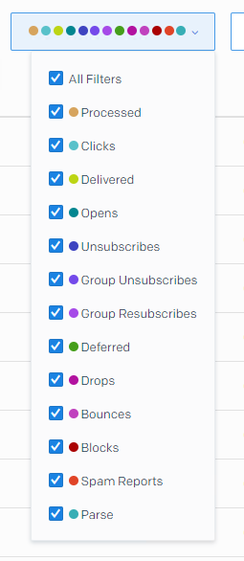

# Additional Configuration

By default, emails sent vis SendGrid are tagged “via sendgrid.me”. To remove this, domain authentication is needed. The SendGrid website has detail information related to the setup and configuration:

<https://sendgrid.com/docs/ui/account-and-settings/how-to-set-up-domain-authentication/>